Enjoy. Embrace. Evolve – We make the difference.
Nursery Newsletter
15.02.2019

What a fantastic half term we have had! Through a range of activities, the children have thrived and learnt all about the different people who help us in our community. We have enjoyed some celebrations, particularly looking at ‘Chinese New Year’ and ‘St Valentine’s Day’ and we were lucky enough to experience playing out in the snow!
Next half term our topic is ‘Rumble in the Jungle’, we will also be celebrating ‘World Book Day’ and having a week full of ‘Science’-We can’t wait! We wish you all a lovely half term, be safe and have lots of family fun!
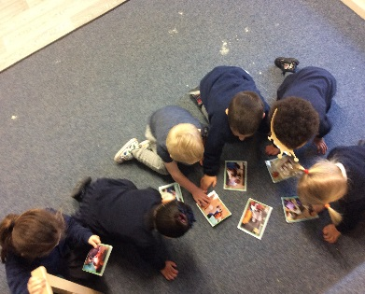
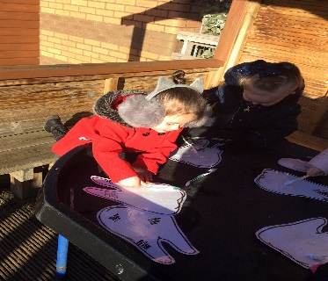
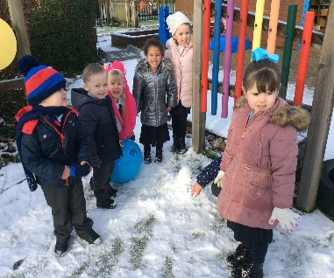
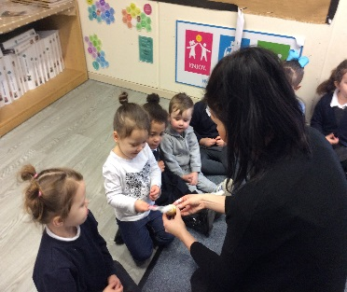

Fire Fighter Visit
We are hoping to have a visit from the fire fighters on the first Wednesday back.
27th February.
If your child does the afternoon session, they are welcome to come to morning session.
Library Art Work
Our Winter Landscape art work is being displayed in the Skelmersdale library. Go and check it out in the half term whilst enjoying a story. Send me a picture on tapestry with the amazing art work we have created. I would love to see how fantastic it looks!

Home Learning
Why not play lots of educational games over the break to keep your little ones busy! There is so much you can do: - get them outside exploring, read lots of stories and play fun number and phonics games. BusyThings is great if your child wants to play on an Ipad!
You can also check out the Easypeasy text and play and adapt those fun activities!

.

Welcome
We would like to say a huge welcome to Sienna who joined our Nursery last week. She is loving Nursery life and comes in smiling every day. We hope you are loving your new Nursery!
.

