PAQ – Responses

What do you think of our school uniform?

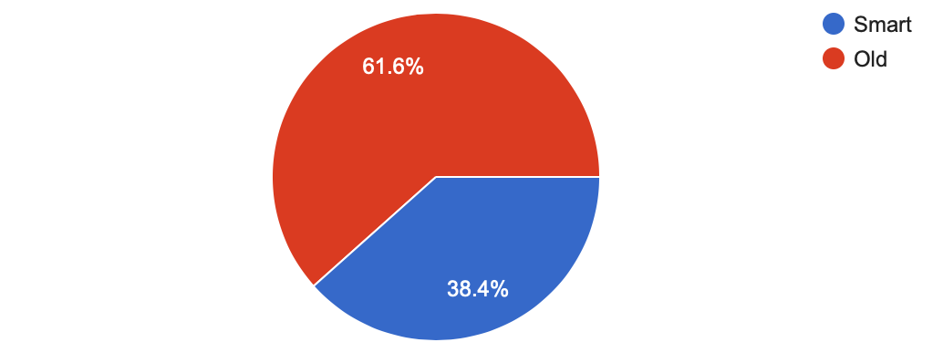
Could our school uniform be better?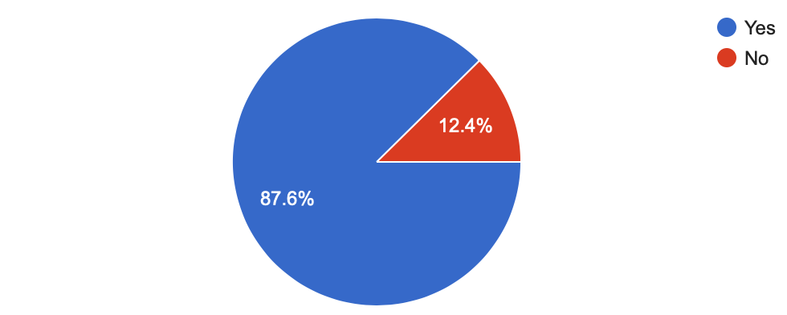
Would you like to wear a tie and blazer in Y5 and Y6?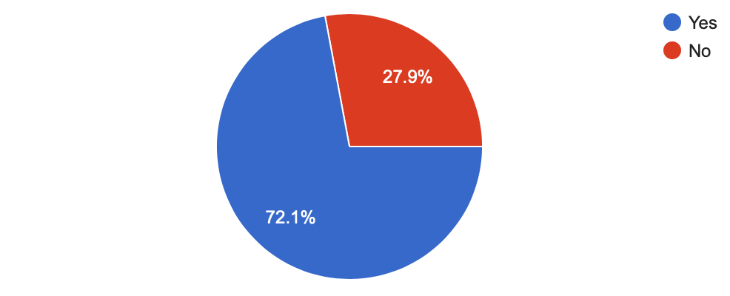
Do you like our current school logo?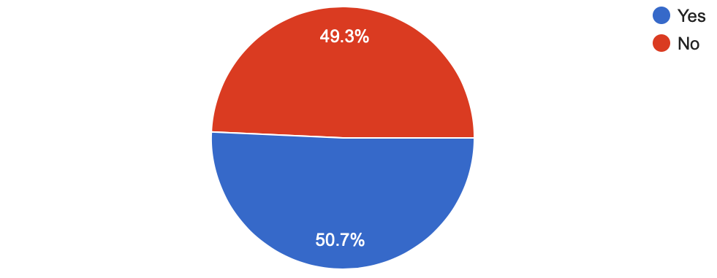
Would you like our school logo to represent our values?
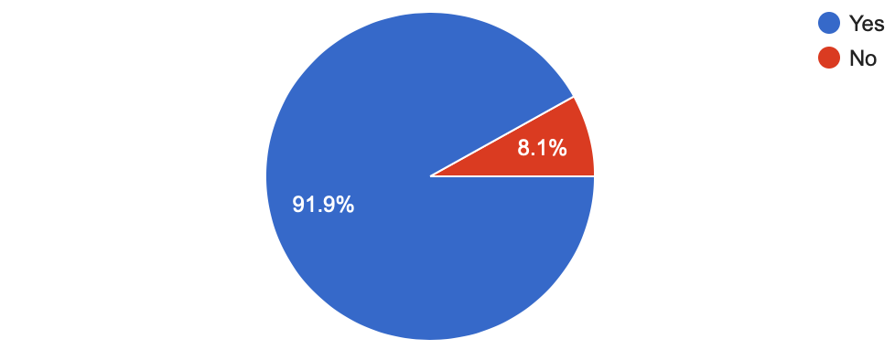

How could we improve our school uniform?
- I really want it to be a different colour because this colour is not very bright like in other schools it is nice and colour full but our uniform is so bland. I have never really liked it at all I just wish that it will change. Also it isn’t very smart because all the Other schools have ties and we don’t it looks like really scruffy.
- To chance the logo to enjoy, embrace and evolve
- Having a different logo
- Different colour/different shade of blue
- Looking smarter
- More style

SAQ – Responses

What do you think of our school uniform?
Do you think our school uniform could be better?
Do you think it would be a good idea for Y5 and Y6 to wear ties and blazers?

Do you like our current school logo?
Would you like our school logo to represent our school values?
How could we improve our school uniform?
- Make is smarter
- All children to wear the same colour t-shirt
- Change the logo to link to our values
- New style, girls in coloured pinafore, coloured t-shirt
- Checked skirts/pinafores for girls. Blue shirts instead of white. Staff could also have coloured polo shirts to match, then the uniform is standard for all.
- Incorporate our values, for a smarter, more professional appearance.
- Modernise our logo.
- We need a more corporate looking logo.

